4 Layouts
Introduction 2
Switching Layouts 2
Standard Layouts 3
3D View full 3
Animation 3
Compositing 3
Default 4
Motion Tracking 4
Scripting 4
UV Editing 5
Video Editing 5
Game Logic 5
Modifying Layouts 5
Maximizing an Editor Window 6
Resizing Editor Windows 6
Splitting Editor Windows 7
Unioning Editor Windows 7
Swapping Contents 8
Make Editor Window floating 8
Change Editor Type 9
Show / Hide the editor type menu 9
Collapse Menus 9
Resize Tool Shelf and Properties content 10
Create new Layout 10
Save changes at the Layout 10
Delete Layout 11
Load Layout from Blend Files 11
Tool Shelf and Properties Sidebar 12
Opening and closing by menu and hotkey 12
Resize 13
Open Sidebar by Plus Button 13
Rearrange Sidebars 13
Header 14
Show / Hide header 14
Flip Header to top or bottom 14
Panels 14
Tabs 15
Pinning panels 15

Introduction

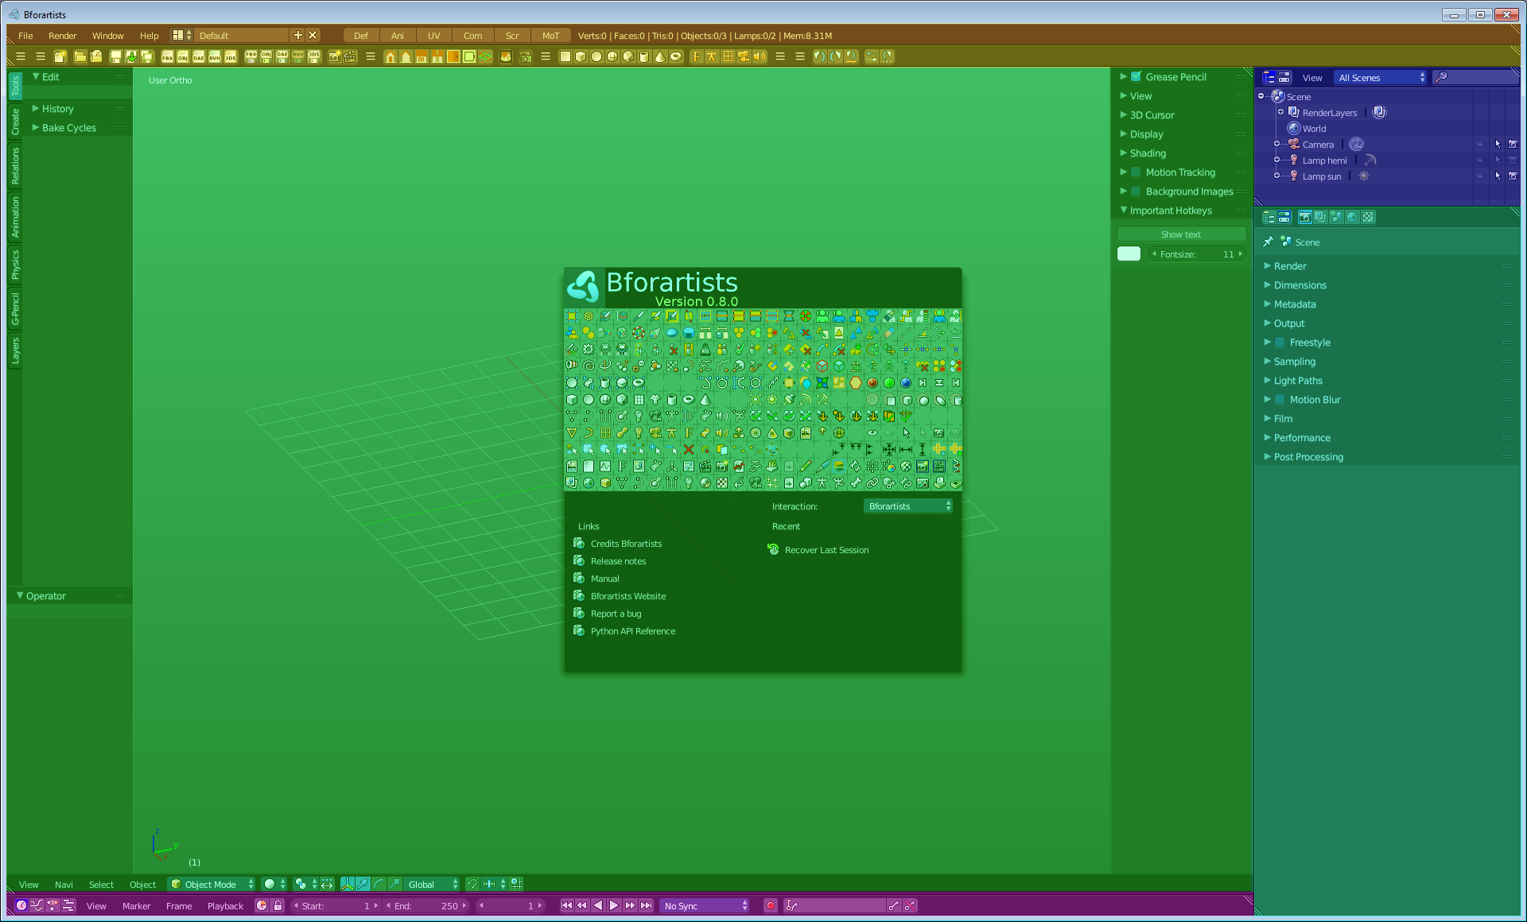
The Bforartists Interface is made of several layouts. We have one for general 3D work, one for scripting, one for UV editing and so on.

And every layout is made of several editors. See image. Which brings the functionality to the layout. Every editor type has another purpose.

The upper menu bar is a editor called Info editor.
Below is the Toolbar editor. The green area is the 3D View editor, the blue little area up right is the Outliner Editor, the bluegreen editor below is the Properties editor. And the collapsed small bar at the bottom is the Timeline.

We will explain the single editors and their functionality and menus in detail at a one by one base. Here we will talk about the layouts in general. The editors are just covered for the layout needs here.

Switching Layouts

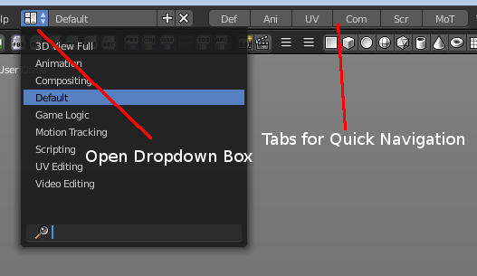
The first important interaction is the ability to switch between the existing different layouts. This can be done in two ways. By the six tabs for quick navigation. And in the layout dropdown box.

The six tabs are connected to the six most important layouts. In the order: Default, Animation, UV Editing, Compositing, Scripting and Motion Tracking.
To switch between layouts by the dropdown box you have to click at this symbol left of the dropdown box. A list will open with the available Layouts. And here you can choose which layout you want to load in the dropdown list by clicking at it.

WARNING!
Do NOT delete the tab button layouts from the dropdown box. This will make the tab buttons disfunctional.

Hint
Just important when you work with more than one scene at once:
By default, each screen layout ‘remembers’ the last scene it was used on. Selecting a different layout will switch to the layout and jump to that scene.

Standard Layouts

The Standard layouts are 3D View full, Animation, Compositing, Default, Motion Tracking, Scripting and UV Editing. Plus a layout for Video editing. And one for the game logic. Both features that are not officially supported by Bforartists. Please use the Blender documentation here.

3D View full  This layout gives you a maximized 3D view that hides every other toolbar and editor. This layout is useful when you want to have a look at the whole scene in a fullscreen manner. It just shows the 3D View Editor. | 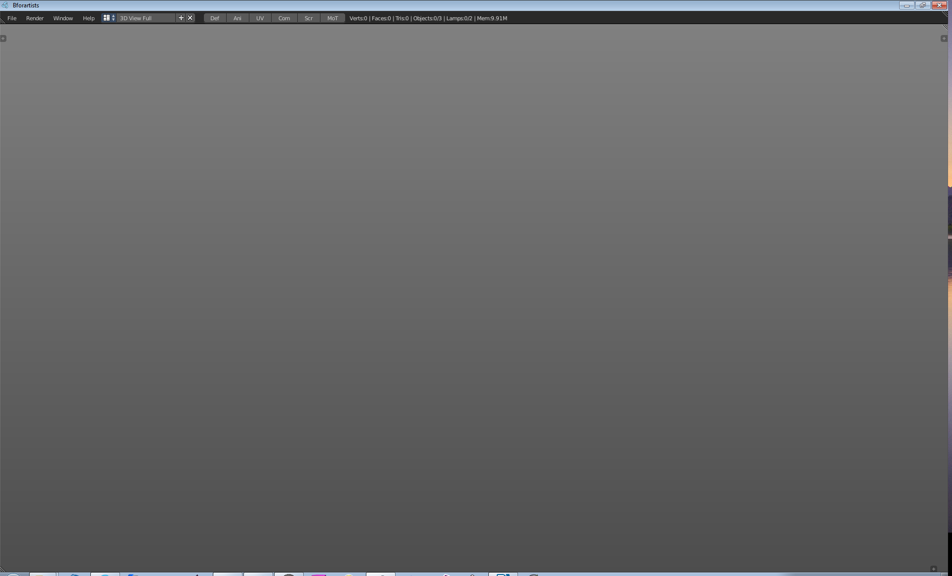
Animation  This layout provides you with a layout that is optimized for Animation tasks. It contains two 3D View editors, a Info Editor, a Outliner Editor, a Properties Editor, a Timeline Editor, a Dope Sheet Editor and a Graph editor. | 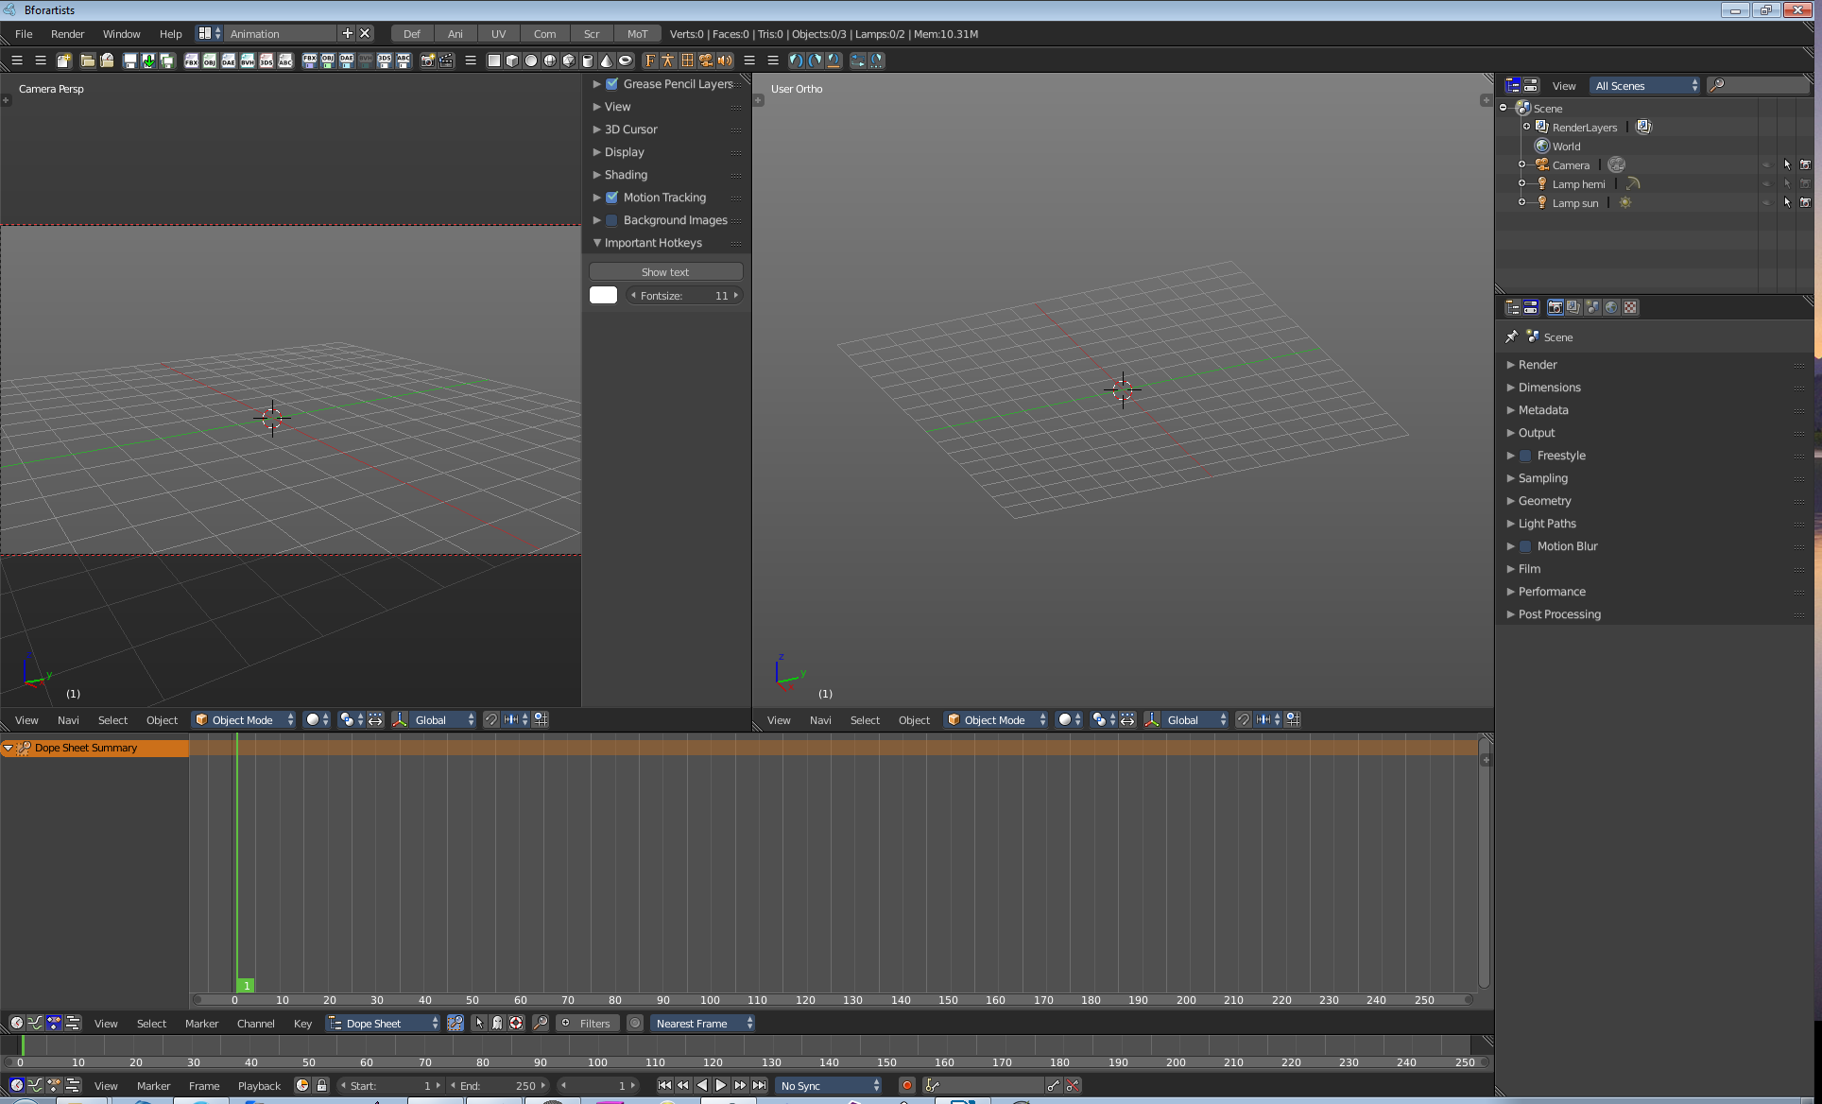
Compositing  This layout gives you a compositing layout. This layout is also meant for working at textures and materials. It contains a Node Editor, a Info editor, a UV Image Editor, a 3D View Editor, a Properties Editor and a Timeline editor. | 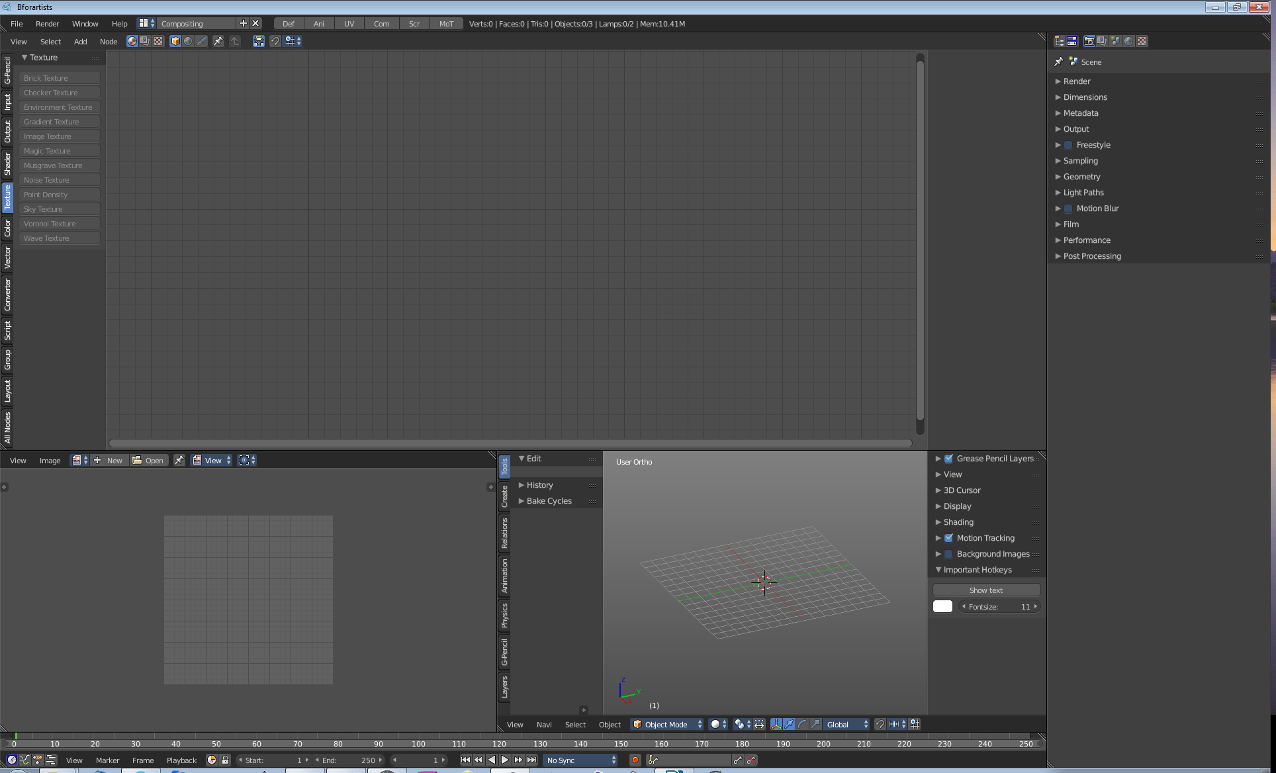

Default  This layout is for general 3D work. Here you work at your 3D scene. Here happens modeling, texturing, etc. It is also the layout with which Bforartists opens up. It contains a 3D View editor, a Info editor, a Timeline editor, a Outliner editor and a Properties editor. | 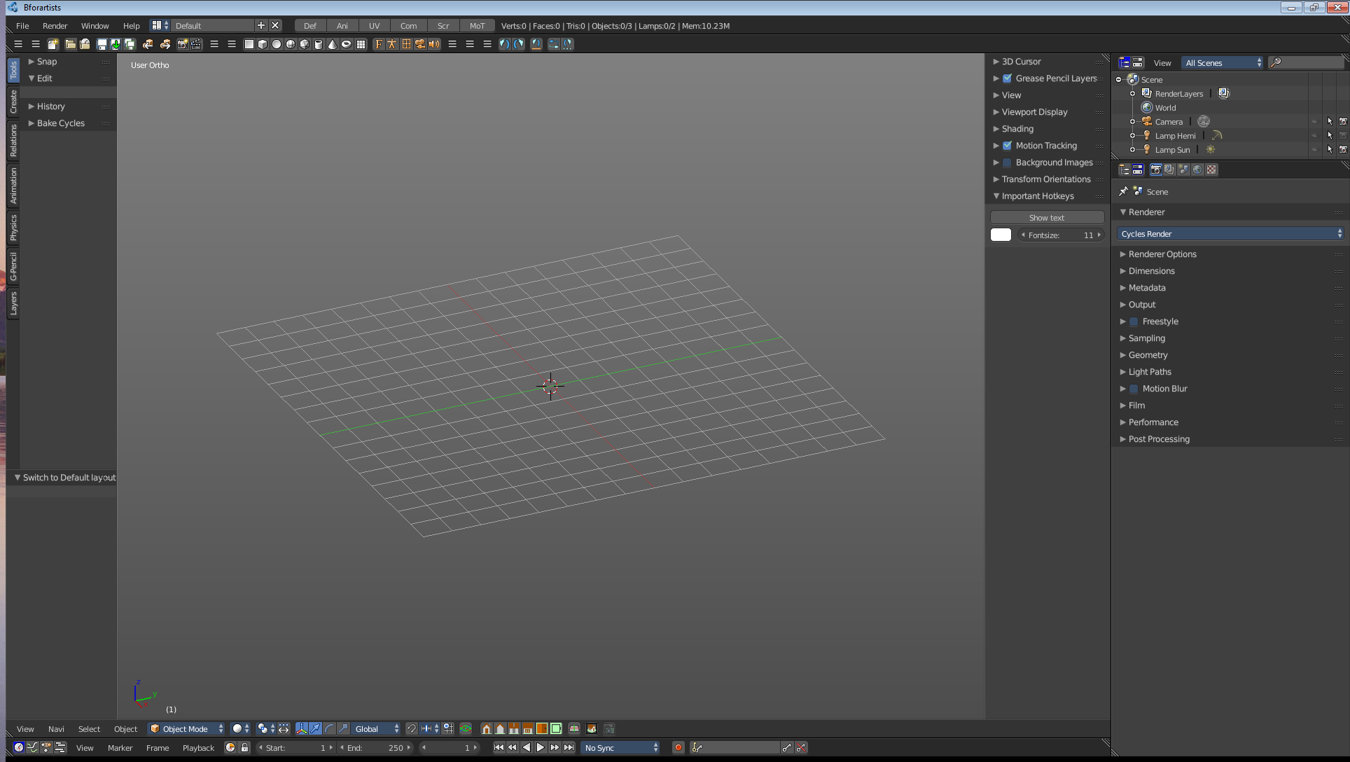
Motion Tracking  This layout gives you a layout for Motion Tracking. | 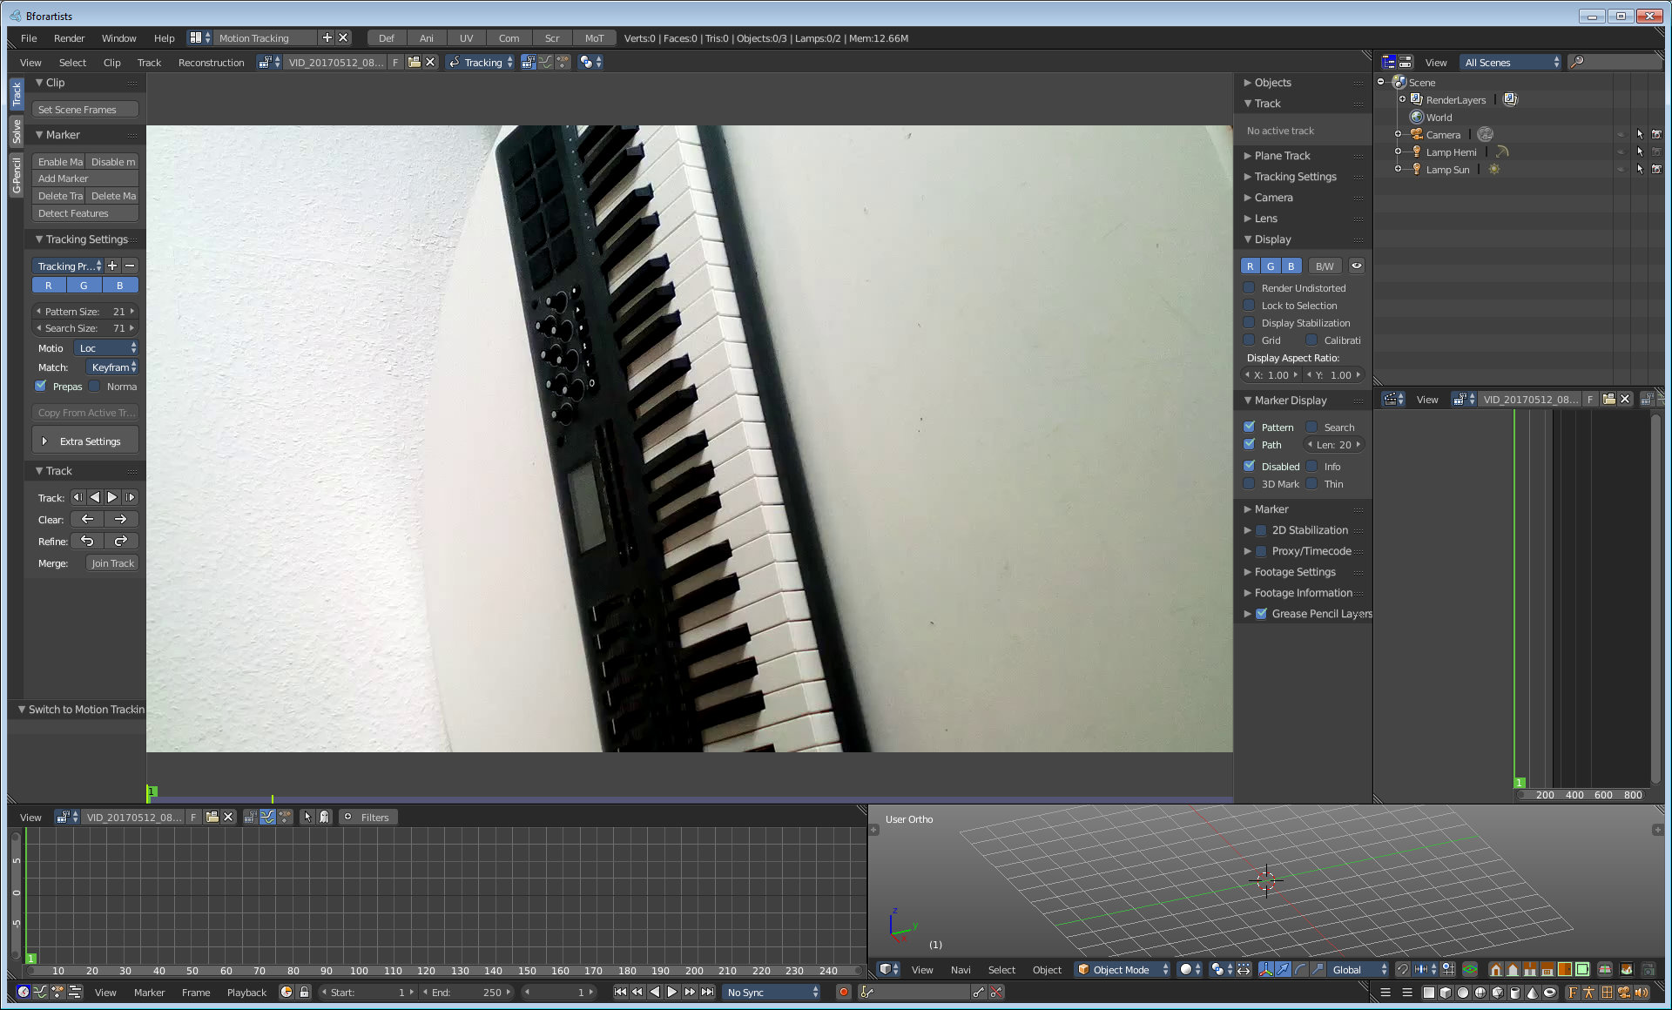
Scripting  The scripting layout gives you a layout where you can write Python code. It contains a Info editor, a 3D View editor, a Console editor, a Text editor, a Outliner Editor and a Properties Editor. | 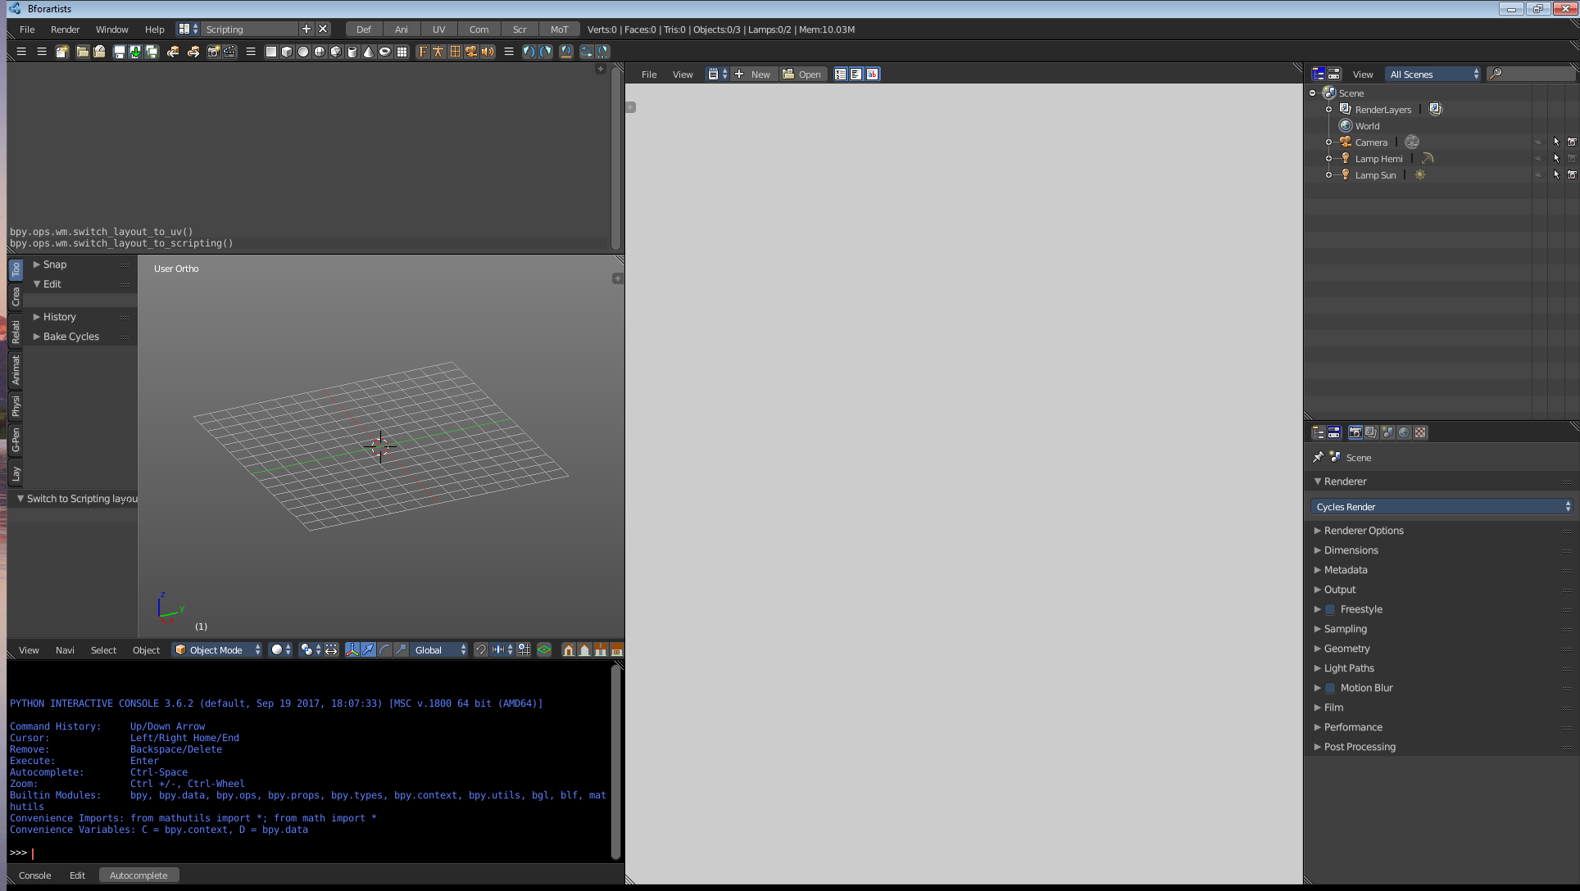

UV Editing  The UV Editing ist made for texturing and UV mapping. It contains a Info Editor, a UV Image Editor and a 3D View editor. | 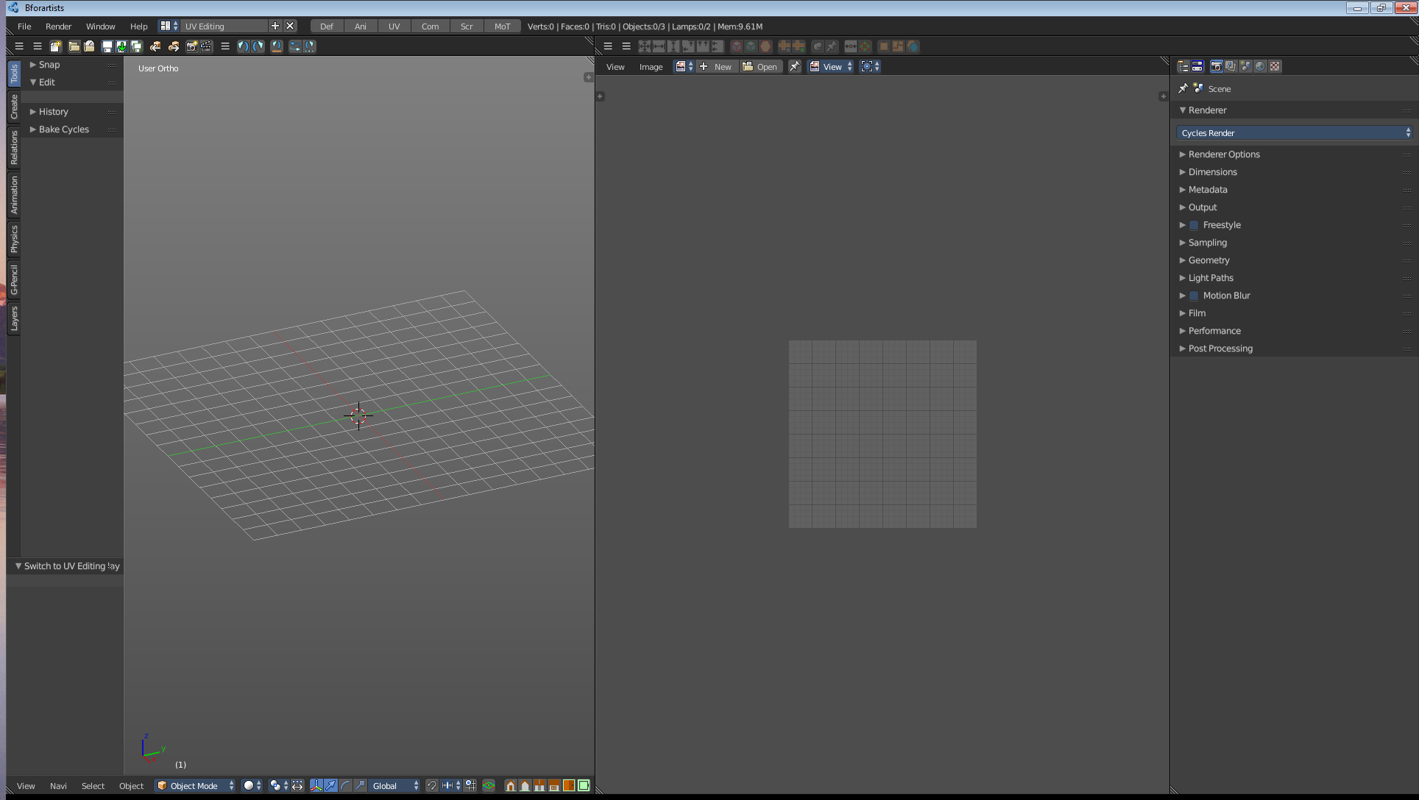
Video Editing  The Video Editing is made for editing videos. It contains a Graph Editor, a Timeline, and two Video Sequence Editors. | 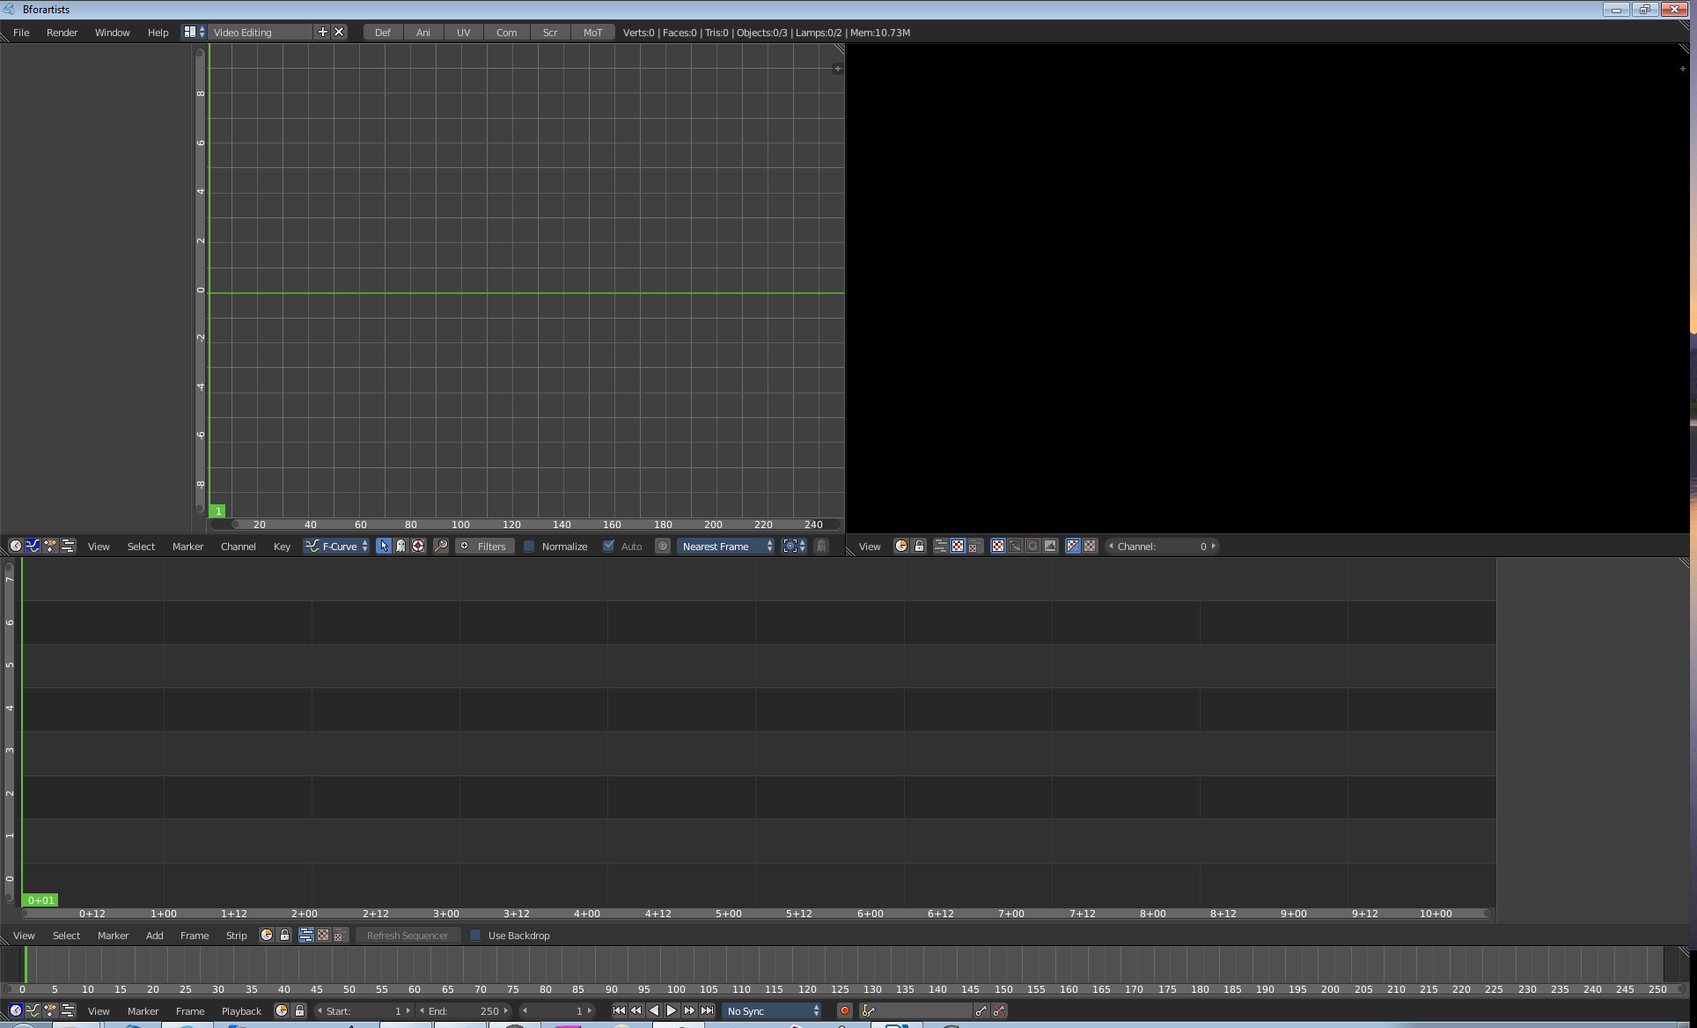
Game Logic  The Game Logic layout is made for developing a game. It contains a Outliner, a Logic Editor, a Text Editor, and a Properties Editor. | 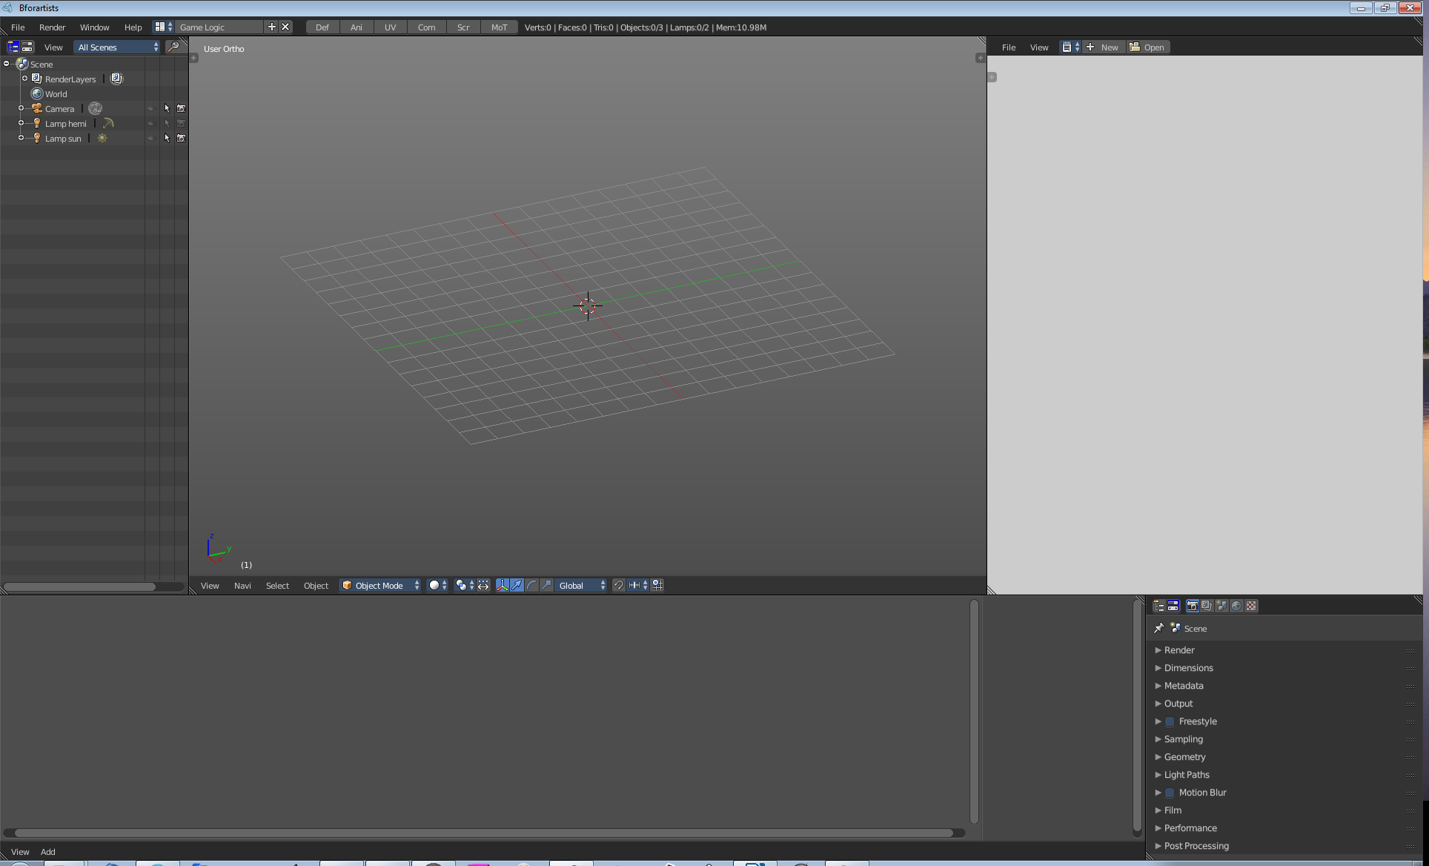

Modifying Layouts

The standard layouts can be modified. You can resize the editor windows, drag-open more editors, drag-close editors away, etc.

Maximizing an Editor Window
You can maximize an editor in the layout to fill the whole screen in the View menu. The menu item Toggle Full Screen. The same menu item will return the editor back to its initial state. This feature is dependant of the mouse position when you use the hotkey. The editor under the mouse will be maximized.

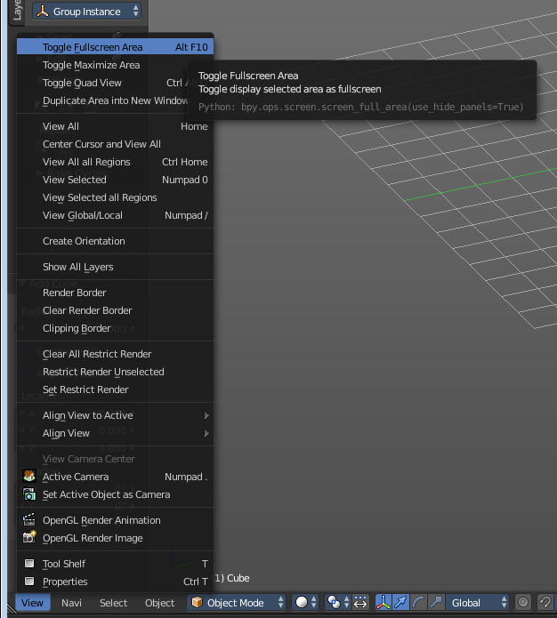

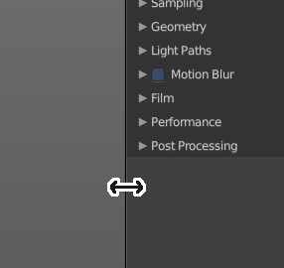
Resizing Editor Windows
Move the mouse over a border between the editors. The mouse cursor will turn into a double arrow. Drag the arrow around and the editor will resize with your moving mouse.

In the Default layout there are two editors that are collapsed to just show the menu. The menu bar at the top is a own editor. The Info editor. You can drag it down to reveal a text field. Here Bforartists displays all the former actions as strings. When you create a primitive for example, then it displays a string with the python command for it.

The other collapsed editor is at the bottom. The timeline.

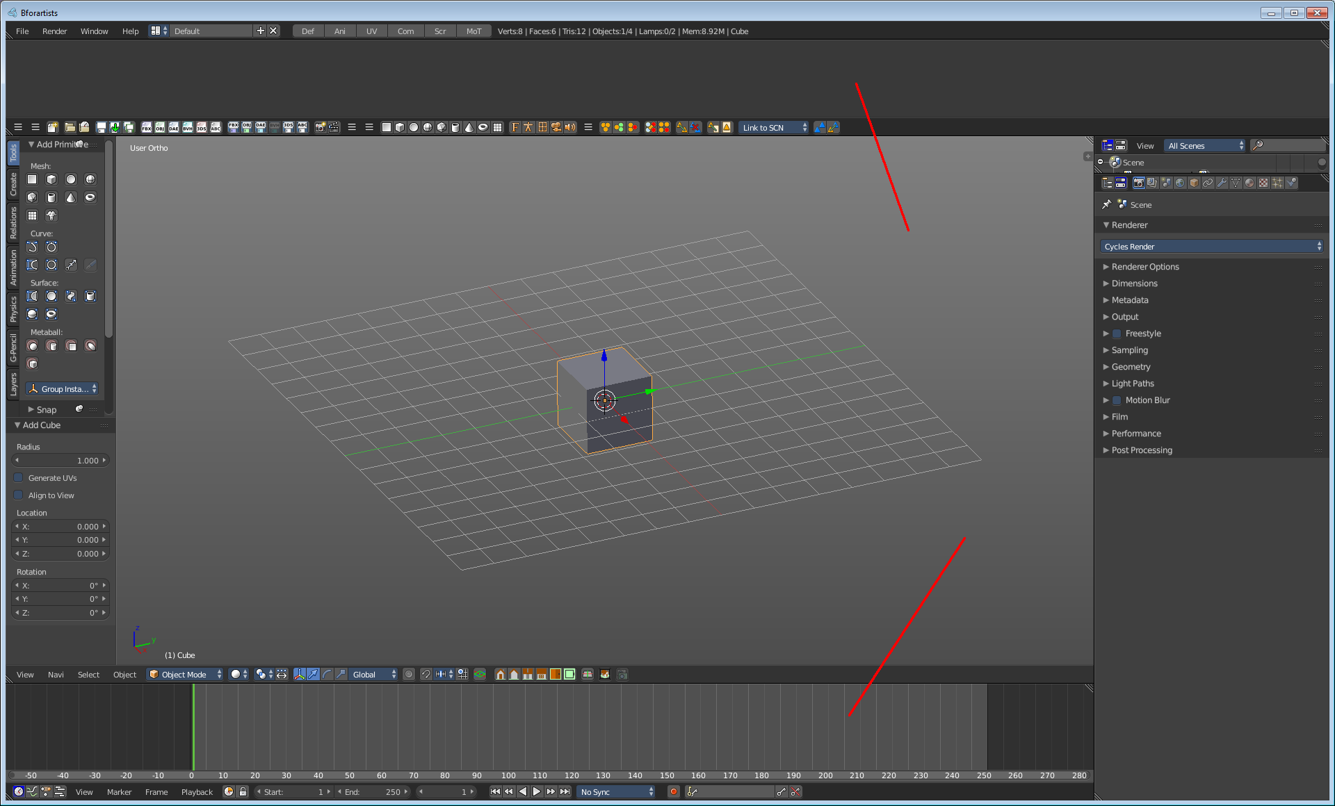

Splitting Editor Windows
There is a little triangle area in the upleft and downright corner of the editors. When you move the mouse over it then the mouse pointer turns into a white cross.

When you click and drag the mouse inwards of the current editor, then the editor splits up. You open a second 3D view for example.
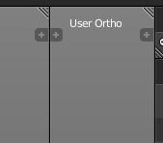
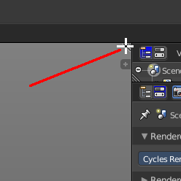

Unioning Editor Windows
There is a little triangle area in the upleft and downright corner of the editors. When you move the mouse over it then the mouse pointer turns into a white cross.
When you click and drag the mouse outwards of the current editor, then the editor unions with the neighbour editor. Note that this just works when they are in one row, horizontally or vertically.
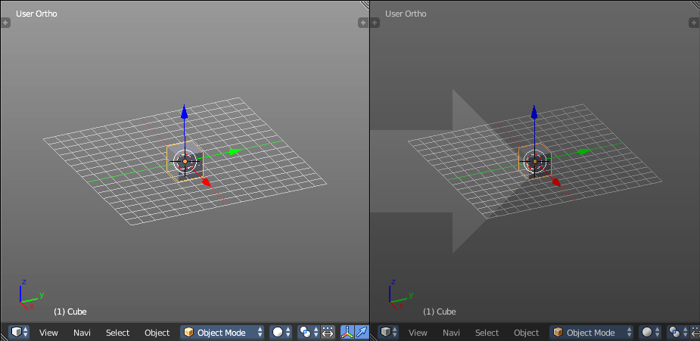
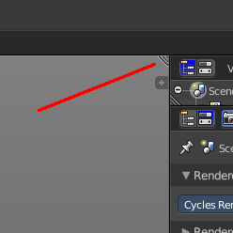

Swapping Contents
You can swap the contents between two editors with clicking at the triangle area, press Ctrl-LMB and drag into the target editor.

Make Editor Window floating

There is a little triangle area in the upleft and downright corner of the editors. When you move the mouse over it then the mouse pointer turns into a white cross.

Hold down Shift, and drag the mouse. The editor will detach from the Blender surface. This is useful for a multi monitor setup for example. Now you can place this editor at Monitor 2.
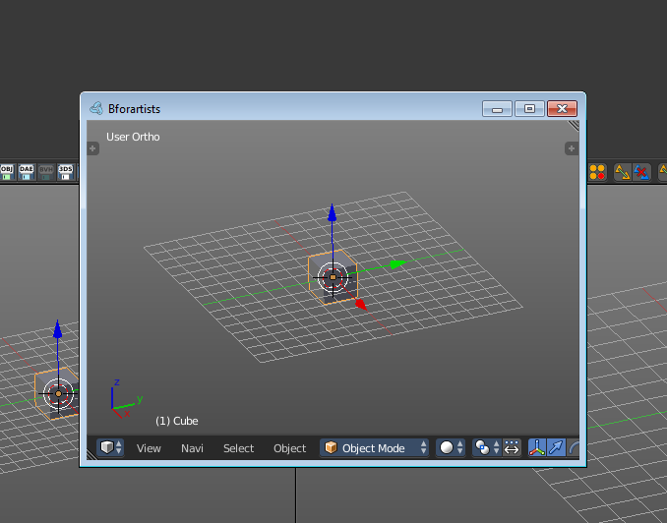

Note that there is no way to reintegrate this floating editor window back into the Blender UI once it is detached. You have to close it.

Change Editor Type

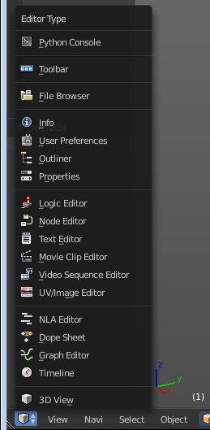
When you split an editor then you get a second editor window. This is of the same type than the original editor window. Means when you have split the 3D View then you have two 3D views now. But with a little difference. It has the so called Editor Type menu visible.
Have a closer look at the menu bar of the new created editor, at the left. Here you can find the Editor type menu in the new created editor. This is the place where you can change the editor type for the new created editor.
You can also change the editors in the standard layouts to something else. You just need to show the Editor Type Menu there, and then you can change the editor type also there. See next point.
A closer explanation of the single editors follows in the chapter Editors.

Show / Hide the editor type menu

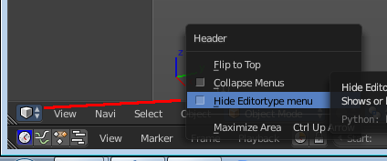
You might have noticed that the editor type menu is not available in the editors of the standard layouts. This is to reduce visual noise and to free some UI space.
You can show and hide this editor type menu. To do so right click at an empty space somewhere at the menu bar of an editor. You will see a menu now. And here you can check or uncheck the menu item Hide Editortype Menu to show or hide the Editor Type menu.

Collapse Menus

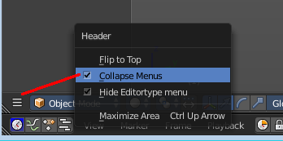
The text menus can be collapsed to free some UI space. Right click at an empty space somewhere at the menu bar of an editor. You will see a menu now. Here you can choose if you want to display the text menu collapsed or expanded.

Resize Tool Shelf and Properties content

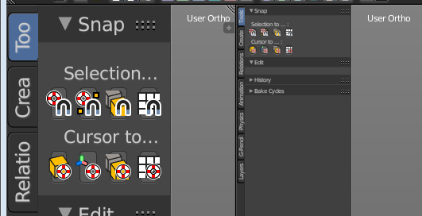
You can resize the Tool Shelf content and the Properties Sidebar content. This means that you can zoom in or out. This trick also works in the Properties Editor.
Move the mouse over the upper region of the Tool Shelf.
Hold down Ctrl key
Click with Middle Mouse button. The mouse pointer will turn into two white triangles.
Now drag up or down to resize the area content

OR

Move the mouse over the upper region of the Tool Shelf.
Simply press Numpad + or Numpad -
To reset the area content to default scale move the mouse over the area and press Home key ( german keyboard layout Pos 1)

Create new Layout
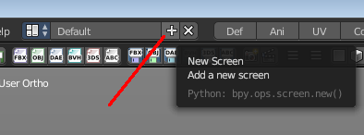
You can either modify an existing layout. Or you can create a new layout. And do your modifications there.

This can be done in the upper menu bar. Have a look at the plus sign at the right of the dropdown box.
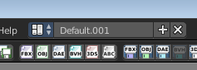
Click it, and you will get a new layout in the text field. The new layout will be based at the layout that you had loaded when you clicked the plus button.
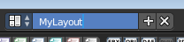
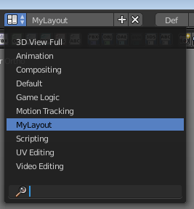
Now rename the layout. Click in the text field and change the layout name to whatever name you want.
It will be part of the layout list now. But just as long as you haven't closed Bforartists. When you want to keep the new layout and the changes at it, then you need to save the modifications. See next point.

Save changes at the Layout
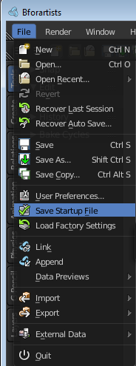
You cannot save new layouts or modifications at an existing layout directly. To save modifications at an existing layout you have to save the Startup File. This menu item can be found in the File menu.

Note that this also affects other changes. Bforartists will for example now start with the currently active layout. And it will also preserve the changes that you did at other layouts before saving.

So when you work at a layout be sure that you don't accidentally do changes at other areas. And before you save the startup file you should switch back to the layout with which you want to start Bforartists.

Delete Layout
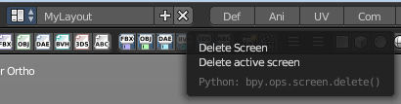
Layouts can also be deleted. To do so simply click at the X button besides the dropdown box.

That's just half of the job though. When you reopen Bforartists then the layout is back. When you want to remove the layout permanently then you have to save the Startup file. See above.

WARNING!
Do NOT delete the tab layouts from the dropdown box. This will make the tab buttons disfunctional. And you will get a warning when you click these buttons.

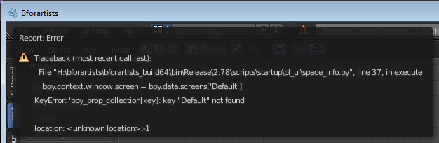
The tab layouts are: Default, Animation, UV Editing, Compositing, Scripting and Motion Tracking.
In case you have deleted them accidentally, simply readd them.

Load Layout from Blend Files

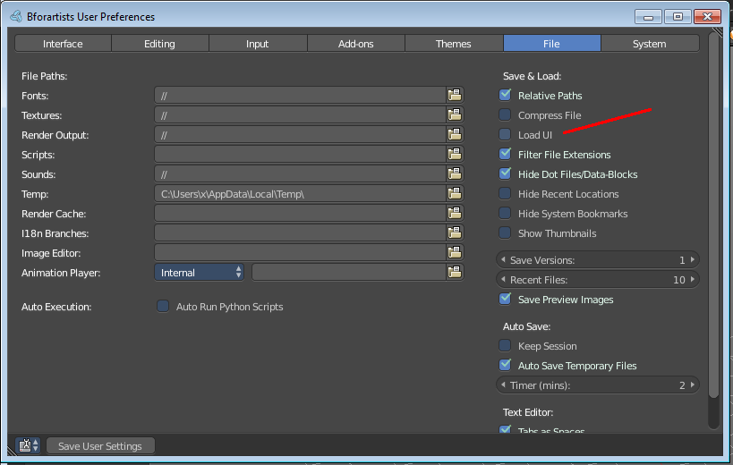
Every blend file saves also the layout in which the scene is at the point of saving. Means you can load a layout from the blend file.

This feature is off by default since it is usually unwanted behaviour to load layouts from other people.

You can turn it on in the User Preferences in the File tab. Tick the menu item Load UI. Then save User Settings.

Note that now all Blend files that you open will load the layout that the Blend files are saved with.

Tool Shelf and Properties Sidebar
Some editors have a Tool Shelf or a Properties Sidebar. Or both. They can be resized by dragging. They can be closed and opened. They can even be rearranged to be left or right. The screenshot shows the 3D view. Left is the Tool Shelf. Right is the Properties sidebar.
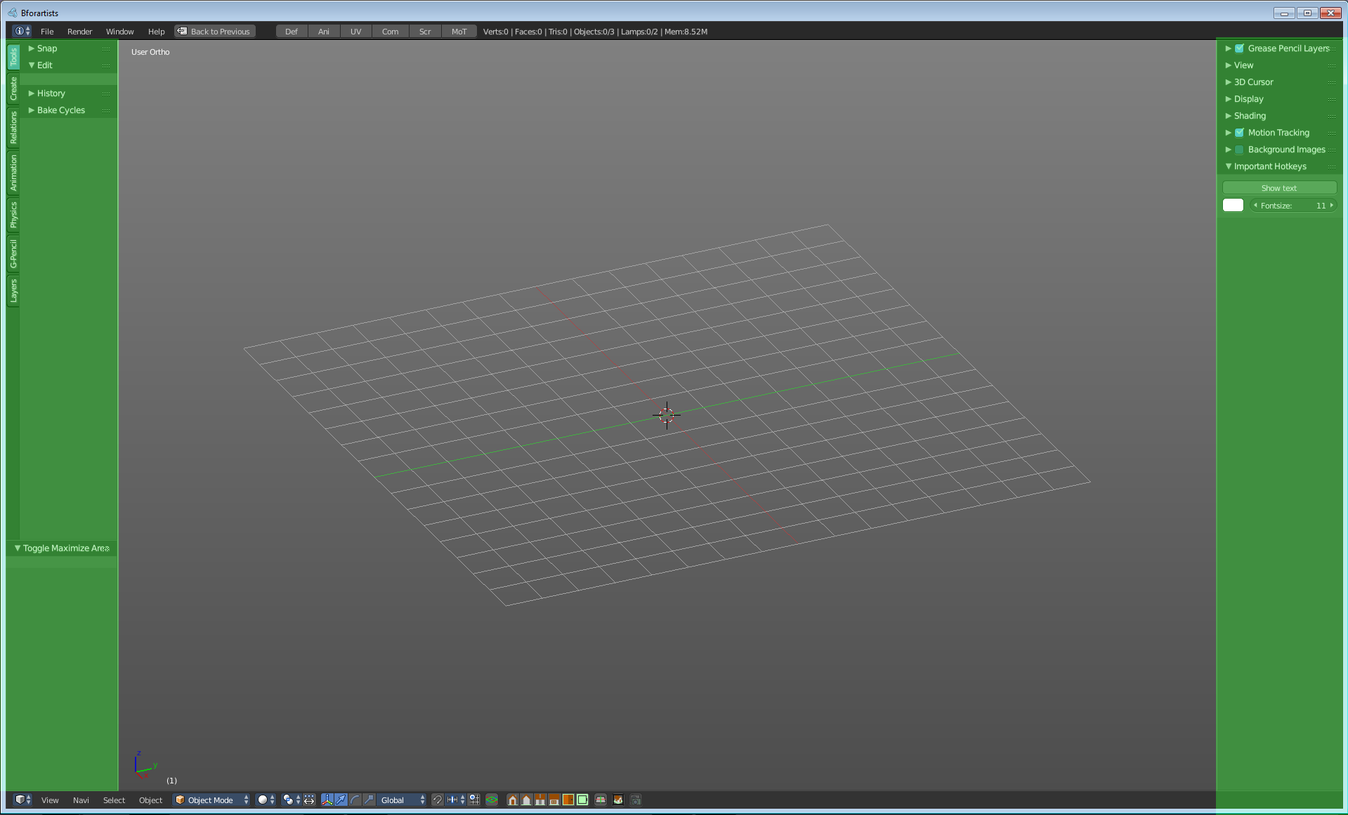

Opening and closing by menu and hotkey
The view menu provides you with menus to close and to open the Tool shelf and the Properties sidebar.
It also shows the hotkeys for those two items.
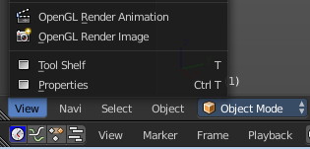

Resize
You can grab the border and drag the Tool Shelf and the Properties Sidebar to the left or to the right to expand or to close them. Text buttons will stretch across the whole width. But the icon buttons will not follow. They have a fixed width of four icon buttons per row.
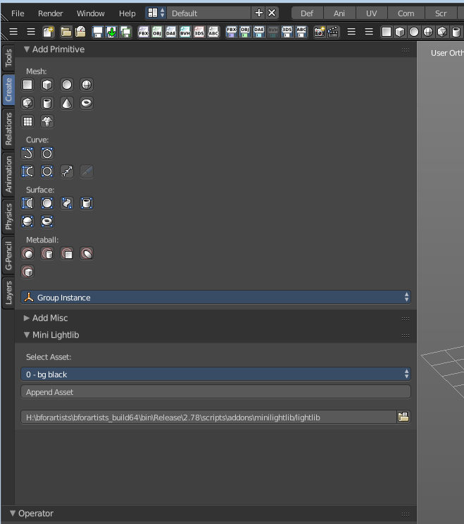
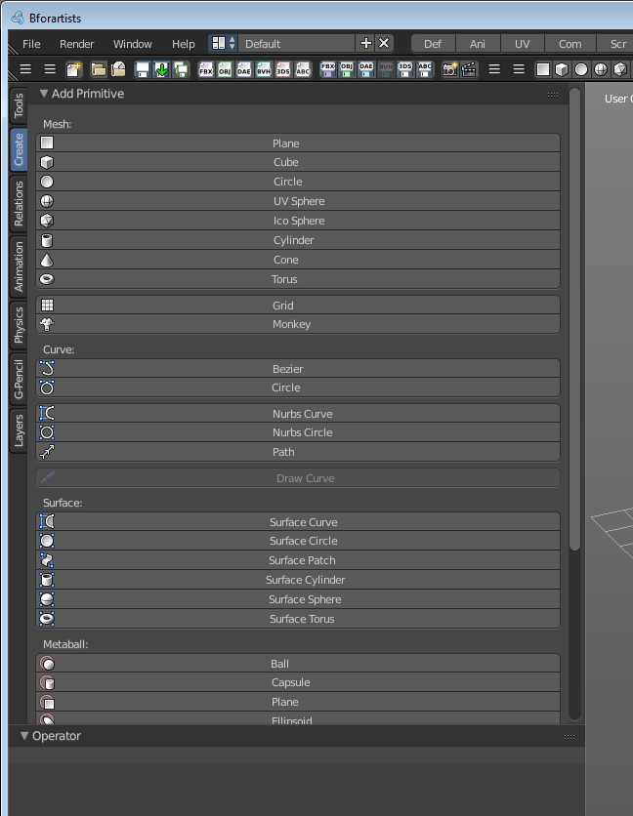

Open Sidebar by Plus Button
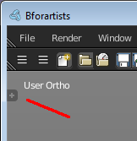
When a sidebar is closed then you will see a little plus button. When you click at this button then the sidebar will reappear.

Rearrange Sidebars
The sidebars can be rearranged to be shown at the left side or the left side. To do so move your mouse over one sidebar, and press F5. The sidebar will jump to the other side now.
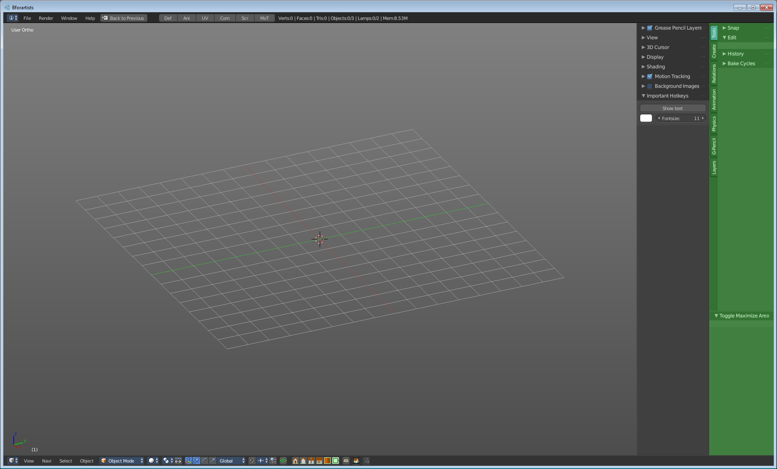

Header
´
Every editor has a header area. It usually contains the menu. And some tools or settings.

Show / Hide header
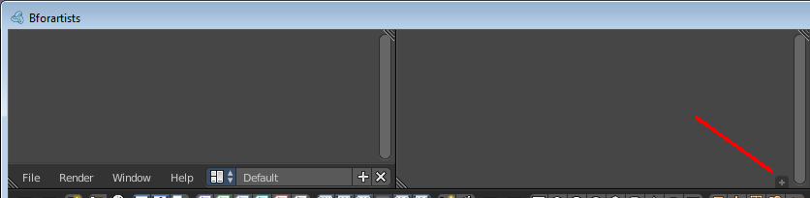
You can hide the header by simply dragging at the border to close it. A little plus button will now show. When you want to reveal the header then click this plus button.

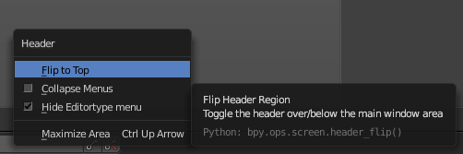
Flip Header to top or bottom

The header can either be displayed at the top or at the bottom.
Right click at an empty space somewhere at the menu bar of an editor. You will see a menu now. Here you can choose if you want to display the menu bar at the top of the editor, or at the bottom.
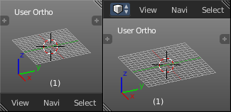

Panels
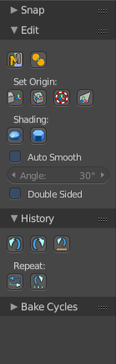
A Panel is a container that contains tools and settings. At the right you see the History panel.

Panels can be rearranged in order. Simply drag them over each other to achieve the order that you need.

Panels can be expanded and collapsed by clicking at the title bar.
When you hold down ctrl and click at the title bar then this panel will open, and all other panels will close.

Panels in the 3D View editor are mode dependant. When you are in Edit mode then you might see other panels in the Tool Shelf than in Object Mode.

Tabs
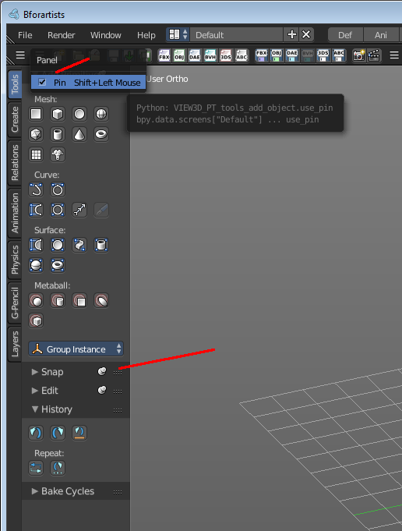
The 3D View editor and the Node editor have Tabs in the Tool Shelf. Tabs. This tabs help to organize the available tools into categories. In the 3D view it's also a common place where addons adds themselves.

Pinning panels

Normally the tabs just displays the panels of the current tab. But you can pin panels so that they display always.
Right click at the tab that you want to pin. A menu pops up. Check the Pin checkbox. The tab will now show a pin, and will display permanently.

To unpin the panel simply click at the Pin icon.

